What Type of Statistical Test Do I Use? How to Apply the Right Kind of Tool for the Job
Statistical Decision Making Resources

Determining What Type of Statistical Test to Use Depends on Several Factors:
- What type of research question are you asking (e.g., descriptive, test of association, testing differences)?
- How many variables are being measured?
- How many of the variables are independent or dependent variables?
- What type of measurement data is being collected (e.g., nominal, ordinal, interval)?
- How is the data structured?
- How many samples are being collected?
- Are the data normally distributed?
- What is the sample size?

Basic Steps in Determining Which Statistical Test to Use:
- Determine what type of research question you are asking and what statistical tests are associated with these types of studies.
- Determine which variables are independent/predictor variables and which are dependent/outcome variables. Determine how many of each are being measured in your study?
- Determine what type of measurement scale is the data you collected?

#1. Statistical Tests for Different Types of Research Questions

Knowing what type of research question your study is asking can often determine what statistical analysis to use. Some types of research questions are:
- Descriptive: Describing a sample or a population
- Comparing groups: Testing for differences between two or more groups. The statistical analysis used can depend on whether the groups come from different samples (independent), or the same samples tested at different time points (paired).
- Associations: Examining the relationships or links between two constructs of interest.
- Predictive: Does increasing (or decreasing) the value on one measure effect the value of another measure.

Statistical Decision Table Based on Goal of Research Study
 | Type of Data
Goal | Measurement (from Gaussian Population) | Binomial (Two Possible Outcomes)
Describe one group | Mean, SD | Proportion
Compare one group to a hypothetical value | One-sample ttest | Chi-square or Binomial test**
Compare two unpaired groups | Unpaired t test | Fisher's test (chi-square for large samples)
Compare two paired groups | Paired t test | McNemar's test
Compare three or more unmatched groups | One-way ANOVA | Chi-square test
Compare three or more matched groups | Repeated-measures ANOVA | Cochrane Q**
Quantify association between two variables | Pearson correlation | Contingency coefficients**
Predict value from another measured variable | Simple linear regression or Nonlinear regression | Simple logistic regression*
Predict value from several measured or binomial variables | Multiple linear regression* or Multiple nonlinear regression** | Multiple logistic regression*
“Review Of Available Statistical Tests” http://www.graphpad.com/support/faqid/1790/
#2. Distinguish Between Independent and Dependent Variables
Next, determine which variables are independent/predictor variables and which are dependent/outcome variables.

Determine how many of each are being measured in your study?

Type | Experimental | Non-Experimental
Independent | Independent Variable: A variable thought to be the cause of some effect. This term is usually used in experimental research to denote a variable that the experimenter has manipulated. | Predictor Variable: A variable thought to predict an outcome variable. This is basically another term for independent variable.
Dependent | Dependent Variable: A variable thought to be affected by changes in an independent variable. You can think of this variable as an outcome. | Outcome Variable: A variable thought to change as a function of changes in a predictor variable.

#3. What Type of Measurement Scale is the Data?
Variables can be split into categorical and continuous, and within these types there are different levels of measurement:

Type | Category | Explanation | Example
Categorical | Binary | There are only two categories | dead or alive; male or female
 | Nominal | There are two or more categories | whether someone is an omnivore, vegetarian, vegan, or fruitarian
 | Ordinal | The same as a nominal variable, but the categories have a logical order | letter grades on an exam;  scales such as none, few, some, many
Continuous | Interval | Equal intervals on the variable represent equal differences in the property being measured | the difference between 6 and 8 is equivalent to the difference between 13 and 15
 | Ratio | The same as an interval variable, but the ratios of scores on the scale must also make sense | a score of 16 on an anxiety scale means that the person is, in reality, twice as anxious as someone scoring 8
Statistical Decision Table

Number of Dependent Variables | Nature of Independent Variables | Nature of Dependent Variables | Tests
1 | 0 IV's (1 population) | interval & normal | one-sample t-test
 |  | ordinal or interval | one-sample median
 |  | categorical (2 categories) | binomial test
 |  | categorical | Chi-square goodness-of-fit
 | 1 IV with 2 levels (independent groups) | interval & normal | 2 independent sample t-test
 |  | ordinal or interval | Wilcoxon-Mann Whitney test
 |  | categorical | Chi- square test
 |  |  | Fisher's exact test
 | 1 IV with 2 or more levels (independent groups) | interval & normal | one-way ANOVA
 |  | ordinal or interval | Kruskal Wallis
 |  | categorical | Chi- square test
 | 1 IV with 2 levels (dependent/matched groups) | interval & normal | paired t-test
 |  | ordinal or interval | Wilcoxon signed ranks test
 |  | categorical | McNemar
 | 1 IV with 2 or more levels (dependent/matched groups) | interval & normal | one-way repeated measures ANOVA
 |  | ordinal or interval | Friedman test
 |  | categorical | repeated measures logistic regression
 | 2 or more IV's (independent groups) | interval & normal | factorial ANOVA
 |  | ordinal or interval | ordered logistic regression
 |  | categorical | factorial logistic regression
 | 1 interval IV | interval & normal | correlation
 |  |  | simple linear regression
 |  | ordinal or interval | non-parametric correlation
 |  | categorical | simple logistic regression
 | 1 or more interval IVs and/or 1 or more categorical Ivs | interval & normal | multiple regression
 |  |  | analysis of covariance
 |  | categorical | multiple logistic regression
 |  |  | discriminant analysis
2 or more | 1 IV with 2 or more levels (independent groups) | interval & normal | one-way MANOVA
2 or more | 2 or more | interval & normal | multivariate multiple linear regression
2 sets of 2 or more | 0 | interval & normal | canonical correlation
2 or more |  |  | factor analysis

“UCLA Stata: What statistical test should I use?” http://www.ats.ucla.edu/STAT/stata/whatstat/default.htm

Other Online Resources for Deciding Which Statistic to Use
- UCLA Stata: What statistical test should I use? This is a good resource that provides several links to how to perform each analysis using statistical software. http://www.ats.ucla.edu/STAT/stata/whatstat/default.htm
- “Review Of Available Statistical Tests” http://www.graphpad.com/support/faqid/1790/
- The Decision Tree for Statistics: This is a good online resource to help guide you through what type of statistical analysis to use based on research design and type of data collected. http://www.microsiris.com/Statistical%20Decision%20Tree/default.htm
- Social Research Methods Selecting Statistics Decision Tree: I find this one to be pretty good because it offers references regarding the statistical tests chosen. http://www.socialresearchmethods.net/selstat/ssstart.htm

Example of Utilizing the Statistics Test Table to Determine What Type of Statistical Analysis to Run

Example:
Students of Megan Dehning’s class, Innovations Public Charter School (HI-SEES, 2011-2012)
“A Comparison of the Abundance and Diversity of Fish Species at Kahalu’u Bay”

Research Question:
Is there a difference in the abundance and diversity of fish close to shore and further from shore at Kahalu’u Bay?

Hypothesis:
We think there will be more fish species in the water farther from shore because there is less human activity and more coral, providing a greater food source.

Procedure:
1. Collect Materials and split into two groups.
2. Lay down a 50 meter transect line in water that is close to shore and in water a further distance from shore. Be careful not to hurt the coral reef while doing this.
3. The fish might also disperse in this process. Give the fish a minute or two to get used to the transect line.
4. Get into pairs with one person on one side and your partner on the other side of the transect line.
5. Count all fish that are within 3 feet of the transect line by putting a tally mark next to that species on the data sheet.
6. Go at the same pace, and if a fish goes from one side to the other, communicate with your partner to determine who will record that fish.
7. When the first pair is about 15 feet ahead, you can send the next pair to start to count the fish.
8. Repeat steps 4 and 5 until everyone in the group has collected data.
9. When you are done, carefully pick up the transect line.

Data Collection:
Fish Names | Water Farther from Shore | Water Closer to Shore
Lined Butterfly | 6 | 0
Achilles Tang | 3 | 2
Convict Tang | 46 | 55
Lavender Tang | 20 | 2
Ringtail Surgeon | 3 | 1
Black Durgon | 2 | 9
Orangeband Surgeon | 8 | 7
Gold Ring Kole | 6 | 0
Orangespine Surgeon | 5 | 2
Bluespine Unicorn | 0 | 1
Picasso Triggerfish | 5 | 2
Bullethead Parrotfish | 6 | 0
Moorish Idol | 0 | 6
Manybar Goat Fish | 1 | 1
Yellow Tang | 58 | 55
Peacock Grouper | 0 | 0
Total | 169 | 143

Results and Conclusions:

Conclusion:
Our hypothesis regarding the total number of fish observed in waters farther from shore versus closer to shore was supported because 54.2% of all fish surveyed were found in waters further from shore.

Worksheet to Determine What Kind of Statistical Analysis to Apply for Current Student Research Projects

- What type of research question is the example asking (e.g., descriptive, measuring associations, measuring differences)?

- Can you identify all of the variables measured by the research project?

- How many variables are there? Is there a distinction between the independent variable(s) (IV) and the dependent variable(s) (DV)?

- What type of data is the measurement collecting (e.g., ordinal, nominal, interval)?

- Using the available resources, can you determine what type of statistical analysis to apply?

Worksheet to Determine What Kind of Statistical Analysis to Apply for Current Student Research Projects

- Write down an example of a current research project that your students may be working on with HI-MOES.

- What type of research question are you asking (e.g., descriptive, measuring associations, measuring differences)?

- Can you identify all of the variables measured by the research project? [fill in the “Variable” column in the table below]

- How many variables are there? Is there a distinction between the independent variable(s) (IV) and the dependent variable(s) (DV)? [fill in the “IV or DV” column in the table below]

- What type of data is the measurement collecting (e.g., ordinal, nominal, interval)? [fill in the “Type of Measurement” column in the table below]

- Using the available resources, can you determine what type of statistical analysis to apply?

- Can the research question be modified or simplified to apply a different kind of statistical analysis?

Table to Help Determine What Type of Statistical Analysis to Use
# | IV or DV | Variable | Type of Measurement (dichotomous, categorical, ordinal, interval)

Worksheet Example of Statistics Calculator Resources

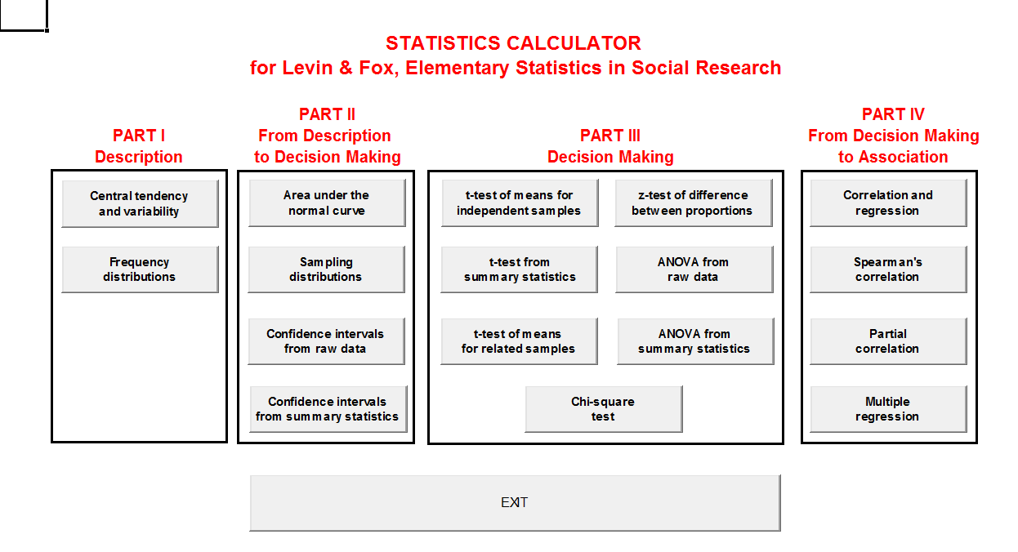

- Download the ABCalc program at: http://wps.ablongman.com/ab_levinfox_essentials_2/75/19394/4964873.cw/index.html

- Using the previous example, “A Comparison of the Abundance and Diversity of Fish Species at Kahalu’u Bay”, determine whether the students were correct.
  - Select options and select the option “enable this content”.
  - Click the button, “Press here for Main Menu”.
  - Select the option “t-test of means for independent samples”.
  - Enter the data from the example under “Group 1” and “Group 2”.
  - Next to “alpha (α)”, select 0.05.
  - Next to “tails (1, 2)”, select 2.

- Examining the chart labeled “Sample Distributions”. What can this tell us about our results?

The Results from My Statistical Analysis Were Non-Significant. Now What?

Review and critique the example of the student’s research study now that you know the results and the nature of the data. Go through each stage of the research process and identify ways that the research study can be improved or altered to investigate this question.

- While examining the findings, are there any further analyses that can be done?

- What new theories or observations can be made from the research findings?

- Should the original research question for the study be revised? How might it be revised for a follow-up study?

- Should the student researchers gather more information on the topic? Were there variables that were unaccounted for in the original study that could be included in a follow-up study?

- What new or different hypotheses could be made in a follow-up study?

- How might the students revise their methods and procedures for a follow-up study?

- Were the data collection needs sufficient to answer the research question?

